# Variables in Java script

What is Variable

How to declare variable

Rules to name a variable

* Variables are three types

1. Var
2. Let
3. Const

Declare

Var num = 20;

We can re-declare var number of times but let and const we cant re-declare.

Hoisting: This concept applicable only for the Var

Example:

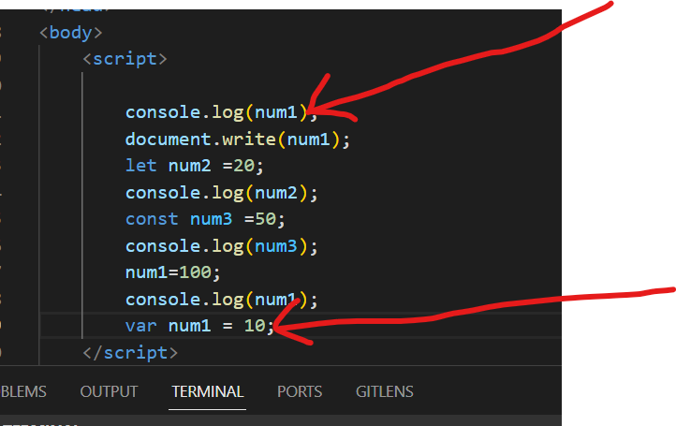

Try to print the value for Var before the declaration and it doesn’t throw and error.

But let and const declaration is required before print.

In let and const try to print before the declaration then It will throw an error.

And IMP point let and const having the block level scope but not for var.

Rules for Variables declaration:

* Should give the var name A-Z or a-z or 0-9 or _or $
* We can start the var name with _ or alphabet.
* Recommendation name is like camel case